**TECHNICAL REPORT ON STUDENT INDUSTRIAL WORK EXPERIENCE SCHEME (SIWES)**

**AT**

**PHYSICAL PLANNING DIRECTORATE, FEDERAL POLYTECHNIC, MUBI, ADAMAWA STATE**

**FROM: 4TH JANUARY, 2023**

**TO: 4TH MAY, 2023**

**BY**

**YAHAYA AHMED BILAL**

**(SE/ARC/ND/21/007)**

**SUBMITTED TO THE DEPARTMENT OF ARCHITECTURAL TECHNOLOGY, FEDERAL POLYTECHNIC MUBI, IN PARTIAL FULFILLMENT OF THE REQUIREMENT FOR THE AWARD OF NATIONAL DIPLOMA (ND) IN ARCHITECTURAL TECHNOLOGY**

**JUNE, 2023**

**DECLARATION**

This is to declare that I, Yahaya Ahmed Bilal with registration number SE/ARC/ND/21/007undertook my four months SIWES at Physical Planning Directorate, Federal Polytechnic, Mubi, Adamawa State and have acquired all the experience compiled in this report in the course of my SIWES.

……………………………….. ……………………………

YAHAYA AHMED BILAL Sign/Date

**CERTIFICATION**

This is to certify that this report compiled by Yahaya Ahmed Bilal (**SE/ARC/ND/21/007**) meets the regulations of governing the award of National Diploma (ND) of the Federal Polytechnic Mubi, and is approved by:

………………………………. …………………………

Name of Supervisor Date

**Departmental Supervisor**

………………………………. …………………………

Arc. Dangana T. Halla Date

**Departmental SIWES Coordinator**

…………………………………. …………………………

Arc. Hussaini Haruna Date

**Head of Department**

**DEDICATION**

I dedicate this project to Almighty Allah and to my beloved parents.

**ACKNOWLEDGEMENTS**

I thank God Almighty for making me to undergo students industrial work experience scheme (SIWES) successfully.

My gratitude goes to my parent for their prayers, financial and moral support during my attachment.

I also appreciate the kind gesture of my brothers and sisters and those who supports me in prayers and contribution during my industrial attachment.

I whole heartedly thank my Head of department Arc. Hussaini Haruna, SIWES coordinator and all lecturers of Architectural Technology for their effort to ensure my success as their students.

I am greatly indebted to my co-SIWES students to mention, may God strengthen our relationship together and grant us academic excellence.

I sincerely thank you all for your contribution and support.

**TABLE OF CONTENTS**

TITLE PAGE………………………………………………………………… i

DECLARATION…………………………………………………………….. ii

CERTIFICATION………………………………...………….………………. iii

DEDICATION………….………………………..………….……………….. iv

ACKNOWLEDGEMENT……………………………………….……………v

TABLE OF CONTENTS…………………………………..…….……………vi

ABSTRACT……………………………………………………….…………. viii

**CHAPTER ONE**

1.0 Introduction……………………………………………………………….1

1.1 Aims and Objectives of SIWES………………………………………….. 1

1.2 Brief history of SIWES……………………………………………………2

1.3 Significance of SIWES………………………………………..…..……… 3

**CHAPTER TWO**

* 1. Brief History of Organization………………………..……........................4

2.2 Organogram……..………………………………………..……................. 5

**CHAPTER THREE**

3.0 Description of work experience……..………………………………….6

3.1 Site layout……..………………………………………..……................6

3.2 Site clearing……..………………………………………..……............. 7

3.3 Setting out……..………………………………………..……............... 7

3.4 Excavation on foundation……..………………………………………..8

3.5 Block work……..………………………………………..…….............. 11

3.6 Architectural designs……..…………………………………………… 11

**CHAPTER FOUR**

4.0 Summary, Recommendation and Conclusion…………………………. 19

## 4.1 Problems observed during my program……………………………….. 19

4.2 Summary……..…………………………………………………………19

4.3 Conclusion……..……………………………………………………….20

4.4 Recommendations……..………………………………………………. 20

Reference. ………………………………………..……................................... 21

**ABSTRACT**

*The report summarises the result of work done during my SIWES experience, the technical report consists of four chapters, which comprises of introduction, history and criteria’s of SIWES in chapter one followed by their aims and objectives, historical background, organizational structure of the organization in chapter two, while chapter three consist of the work actually carried out during the SIWES programme and lastly chapter four consist of the summary, conclusions and recommendation.*

**CHAPTER ONE**

**1.0 INTRODUCTION**

The acronym (SIWES) meaning “Student Industrial Work Experience Scheme” is a skill training designed to expose and prepare student in institution of higher for industrial working situation they may likely meet after graduation. The scheme is meant to train student on the method of work and the experience needed in handling the equipment and machines may not to be available in their institution. The scheme is financed by the Federal Government and operators through Industrial Training Fund (ITF), Ogwo, (2001) and operates with National University Commission (NUC), National Board of Technical Education (NABTEC), and National Commission for College of Education (NCCE) and industries. However, SIWES also expose the student to many practical works which the institution did not treat in details without plastering what the institution taught theoretically into practical. A point from academic obtained. SIWES assist the student to understand the nature of his/her work in future.

## 1.1 Aim and objective of SIWES

ITF initiates SIWES with the sole aim of: Exposing student with the practical experience related to the theoretical knowledge acquired in school. Bridging the gap between theoretical learning and practical work situation.

1. To make industries/organization to have confidence in the abilities and capacities of the graduates. SIWES helps the industries to evaluate the prospective employees and give feedback to the institution.
2. It helps the student to gain work and also have experience and confidence as a result if successful completion of a given job assigned to them.
3. To enlist and strengthen the employers’ involvement in the institution activities and in the entire educational process of preparing the student for meaningful and productive employment into industries.
4. It provides an avenue for student in the Nigerian University and Polytechnics to acquire industrial skill and experience in their course of study.
5. Development for greater understanding in other people and proffers skills in human relations.

## 1.2 Brief history of SIWES and ITF in Nigeria

It was said by Dr. Azikiwe Nnamdi, the one president of Nigeria that the practice of work but they all have the same goal that they all want to achieve in countries like china. They established within the premises of institution to provide real life situation, lack of practical skill of locally trained engineers and technologies. the chine way and condition of SIWES is that all institution must give student real life working experience in industrial works. Lecturers are involved in the industrial activities rendering constant services. So, all these countries have their own way of conducting the scheme but all lye on the same goal. And in Nigeria, the history of SIWES can be traced by the history of IITF which is the backbone of SIWES. ITF was established in 1974 under degree of 47 of 1971. It was a body established by the Federal Government of Nigeria and was given responsibility of training indigenous Nigerians. The establishment of the body became necessary due to high demand of Nigeria to take up the vacant positions created in various sector of the economy after the colonial masters have departed. Therefore, the Federal Government discovered that it is easier to train students that are skilled in school to be trained and meet up with gaps in the Nigerian economy and a scheme was established to care for such training and it was named Student Industrial Work Experience Scheme (SIWES). In 1973, the national board of technical education (NBTE) made it compulsory for all the polytechnic students, be it federal or state.

## 1.3 Significance of SIWES to students

Principles taught in the classroom are vein forced given concrete applications on the industrial assignment and students is able to see the relevance of their students which increase their motivation. It helps in given students the knowledge on the types of work to do after his/her graduation. SIWES given students opportunity for a change of environment as they move their institution to the place of attachment which changes the routine types of environment to a word of work. It helps in connecting the institution and the industrial their relationship the introduction of SIWES.

**CHAPTER TWO**

**2.1 BRIEF HISTORY OF Physical Planning Directorate, Federal Polytechnic, Mubi, Adamawa State**

The Physical Planning Directorate, Federal Polytechnic, Mubi, Adamawa State, was established in the year 2009, with the sole aim of planning, design, construction and supervision of new project in the Federal Polytechnic, Mubi be it in contract or direct labour. And procurement and preparation of land document.

The following are some units in the Physical Planning Directorate, Federal Polytechnic, Mubi;

**Architecture**: Responsible for design and supervision of construction works in the Polytechnic.

**Civil Engineering**: Responsible for the supervision of construction of structural element during construction.

**Building Tech**: Responsible for supervision and quality control.

**Town planning**: Planning and maintaining the layout plan of the polytechnic.

**Quantity surveyor:** Participates in tendering, preparation of contract document, valuation etc.

**Craft men:** Assist the professional in carrying out their duties

**Admin**: The Administrative staff supports all the staff in the directorate.

**2.2 COMPANY ORGANOGRAM**

**DIRECTOR OF WORKS**

**TOWN PLANNERS**

**PRINCIPAL TOWN PLANNERS**

**ARCHITECTS**

**ADMIN**

**ENGINEERS**

**ASST. CHIEF TECH OFFICER**

**CHIEF ARCHITECT**

**BUILDING ENGINEER**

**CIVIL ENGINEER**

**PRINCIPAL BUILDING ENGR..**

**ASST. CHIEF TECH OFFICER**

**FOREMAN**

**FINANCIAL TECHNICIAN**

**PRINCIPAL TOWN PLANNERS**

**ASST. CHIEF TECH OFFICER**

**PRINCIPAL EXECUTIVE OFFICER**

**HIGHER EXECUTIVE OFFICER**

**CONFIDENTIAL SECRETARY**

**CLERK**

**LAB ATTENDANT**

Figure 2.1: Organogram

**CHAPTER THREE**

**3.0 DESCRIPTION OF WORK EXPERIENCE**

**3.1 SITE CLEARANCE**

To perform site clearance, the following procedures were typically followed:

**Preparing for Site Clearance:**

1. The site clearance team gathered the necessary equipment and tools, including shovels, rakes, wheelbarrows, chainsaws, and protective gear such as gloves and safety glasses.
2. The team reviewed the site plan and any specific instructions or requirements for the clearance process.
3. Safety precautions were discussed, and any permits or permissions were obtained as needed.

**Clearing Vegetation:**

1. Trees, shrubs, and other vegetation were removed from the site using appropriate tools, such as chainsaws or brush cutters.
2. Vegetation debris was piled and cleared from the area or disposed of in accordance with local regulations.
3. The team ensured that any protected or environmentally sensitive plants were identified and handled appropriately.

**Removing Debris and Obstacles:**

1. Construction debris, such as rubble, bricks, wood, and any other materials present on the site, were gathered and removed.
2. Larger objects or obstacles, such as rocks or concrete slabs, were either cleared or demolished using heavy machinery, if necessary.

**Excavation and Grading:**

1. Excavation equipment, such as excavators or backhoes, was used to dig out any existing foundations, trenches, or unwanted underground structures.
2. The site was leveled and graded, ensuring proper drainage and a suitable foundation for future construction.

**Waste Management:**

1. Hazardous materials, if encountered during site clearance, were handled and disposed of according to relevant regulations and guidelines.
2. Non-hazardous waste, such as vegetation debris and construction materials, were sorted and disposed of appropriately, either through recycling, landfill, or other approved means.

**Site Inspection and Final Checks:**

* 1. Once the site was cleared, a thorough inspection was conducted to ensure that all debris, vegetation, and obstacles were removed.
  2. Any remaining small debris or loose materials were collected and cleared.
  3. The site was left in a clean and safe condition, ready for the next phase of construction or development.

**3.2 SETTING OUT**

345 method are used for the setting out, as observed after 90 from all angles using the pages ropes string and also from the plan.

Setting out is done with high degree of accuracy or else the building will not last as the engineer answered to my question “why are some calculations made during setting out”.

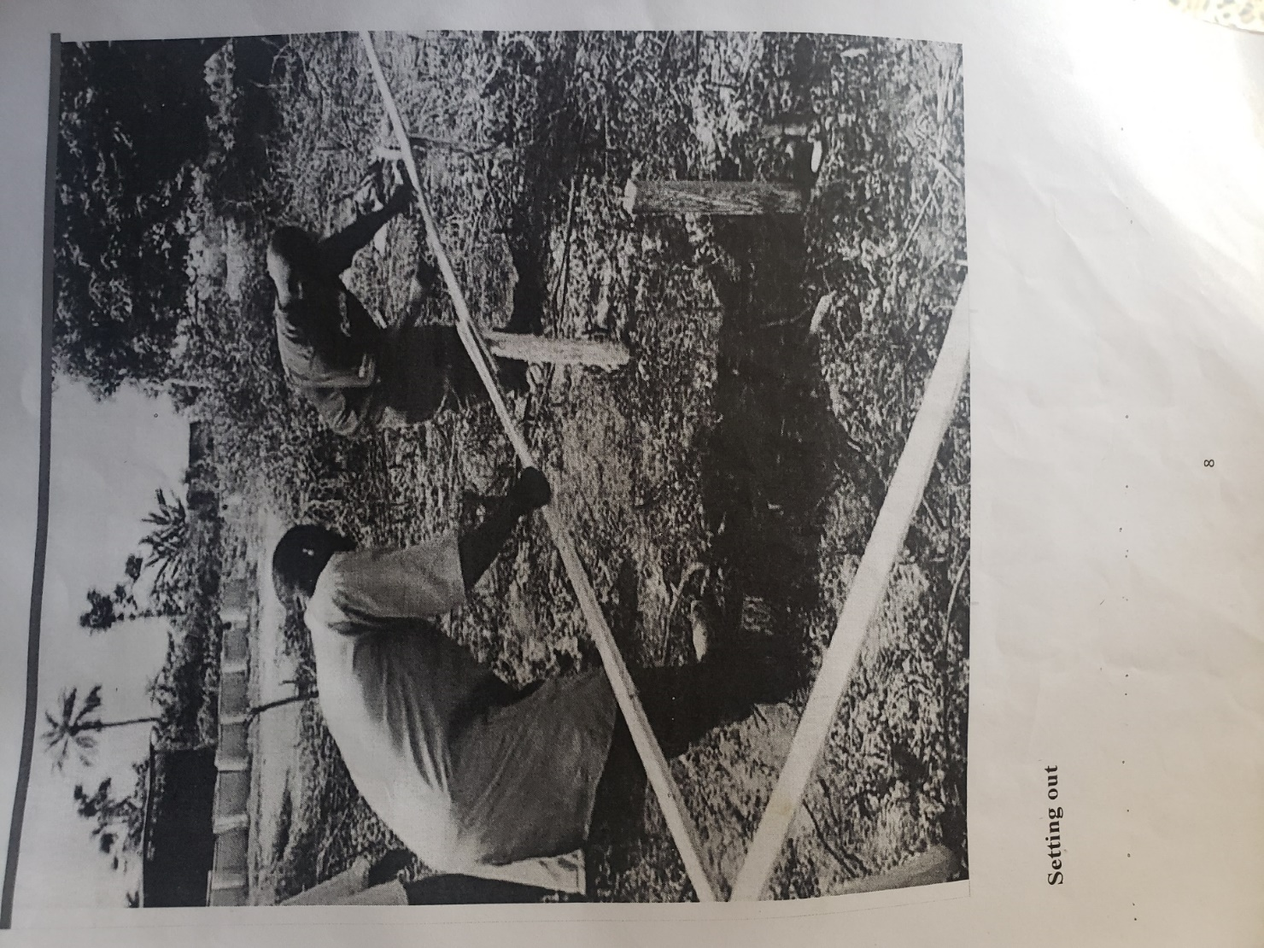

Plate 3.1: Setting out using profile board

Source: Author’s work, 2023

**3.3 EXCAVATION OF FOUNDATION**

Excavation can be defined as the process of digging a soil surface or trench for foundation lay into trench.

It is also the process of removing top soil for foundation trenches. Excavation work is an important part of building operation that commences immediately after setting out the width of excavation for foundation trenches is marked out on the profile and then transferred to the ground. Excavation must be carried out carefully to ensure safety of workers.

Excavation can be done using two methods mechanical and manual. In small construction we normally use manual method while in large construction we use mechanical e.g. like road construction.

Excavation work were carried out manually where unskilled labourer where involved with digger, shovels, head pan and wheel barrow. The following factors must be considered when carrying out any excavation work.

1. Nature of the soil
2. The width and depth of foundation
3. Climatic condition at the time of excavation
4. The water table of the soil
5. The period excavation work is expected to be left open.
6. The effect of excavation on existing adjacent structure.

As the engineer and the former goes to set basket, I was keeping an eye on how the beams were set. When digging the basket some places were 1.2 while some other places were 1.4 by 1.4 because of the type of soil on the site. When putting the basket in a poor soil, cement and sharp sand is mixed out before putting the basket to avoid rusting.

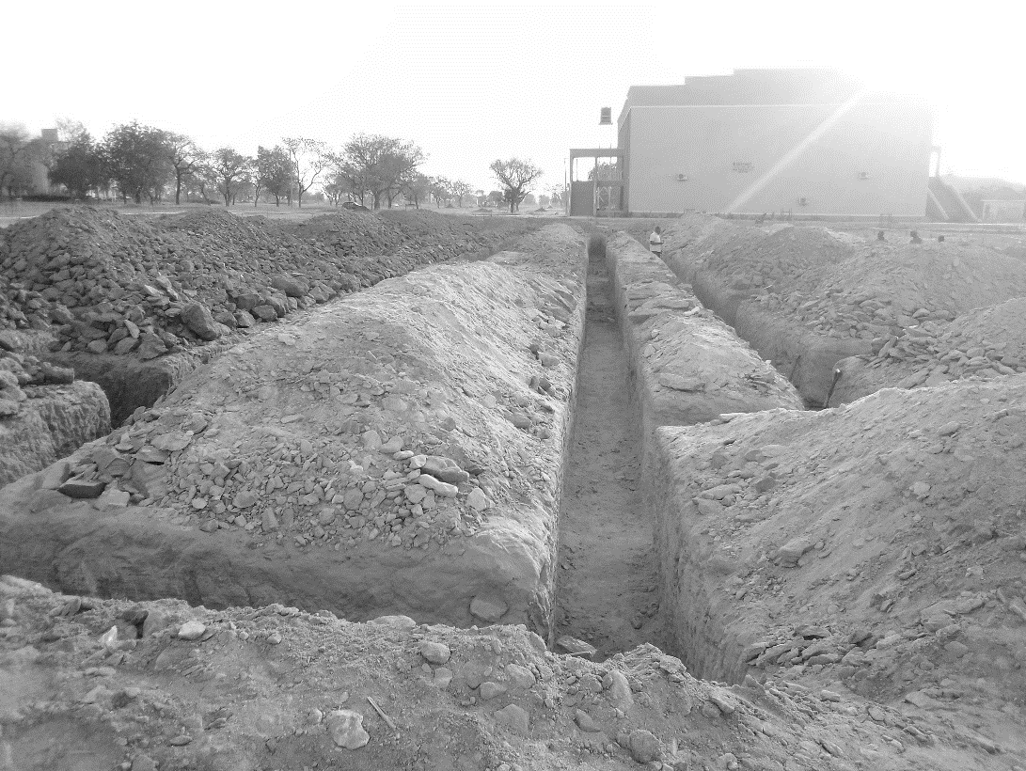

Plate 3.2: Excavation

Source: Author’s work, 2023

**3.4 CALLIGRAPHIC WRITING**

By following these procedures, calligraphic writing was executed skillfully in the, resulting in beautiful and elegant pieces of art or writing.

Here are the steps typically undertaken:

**Gathering Materials:**

1. The necessary calligraphy materials were collected, including calligraphy pens (such as dip pens or brush pens), ink, paper, ruler, pencil, eraser, and a clean workspace.
2. Different types of paper were considered, depending on the desired effect and the type of ink being used.

**Selecting a Style and Design:**

1. A calligraphy style or script was chosen based on the purpose of the writing and personal preference.
2. The text or design to be written was planned and sketched lightly in pencil, ensuring proper spacing and alignment.

**Preparing the Pen and Ink:**

1. If using a dip pen, the pen nib was attached securely, and the pen was tested on scrap paper to ensure proper ink flow.
2. Ink was poured into an inkwell or prepared in a suitable container, making sure it was of the desired consistency and free of clumps.

**Practicing Strokes and Letterforms:**

1. Warm-up exercises and drills were performed to gain control over the pen and understand the basic strokes required for the chosen script.
2. Individual letterforms were practiced repeatedly, focusing on achieving consistent thickness and flow.

**Executing the Calligraphy:**

1. The pencil sketch was used as a guide to write the calligraphy on the final paper.
2. With a steady hand, the pen was dipped in ink and carefully applied to the paper, paying attention to the pressure exerted on the pen to create thick and thin lines as needed.
3. Each stroke and letterform was executed deliberately and thoughtfully, with attention to spacing, proportions, and overall aesthetics.

**Allowing the Ink to Dry:**

1. After completing the calligraphy, the ink was allowed to dry completely, usually for a few minutes or as per the ink manufacturer's instructions.
2. Care was taken to avoid smudging or touching the wet ink during this drying period.

**Making Corrections (if necessary):**

If any mistakes or imperfections were noticed after the ink had dried, they were corrected using appropriate techniques or tools, such as carefully erasing pencil lines or making touch-ups with a fine-tipped brush.

**3.5 ARCHITECTURAL DESIGNS**

During my SIWES, I was able to design a floor plan, lining room, dining area with section and elevation. Fine attached.

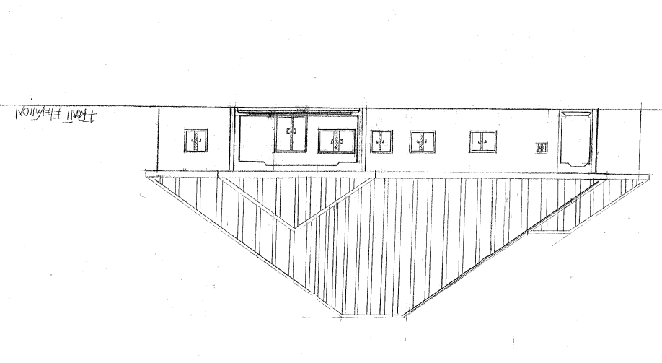

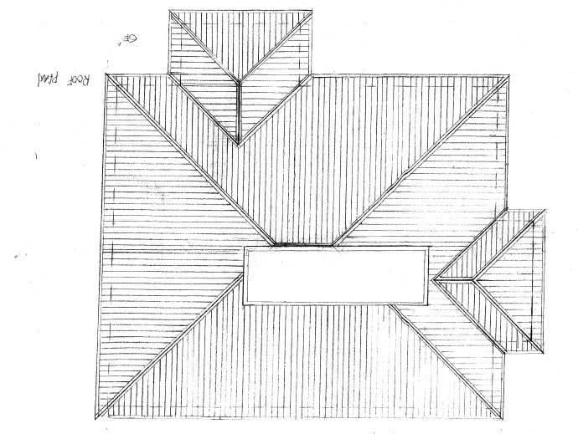

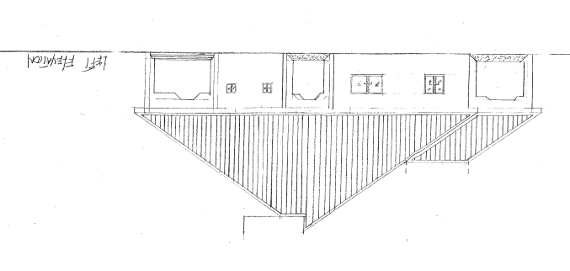

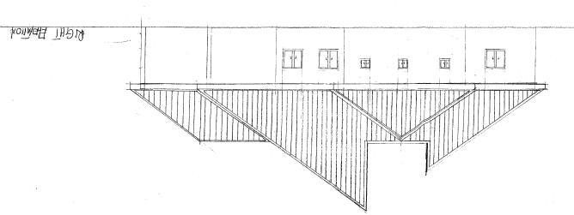

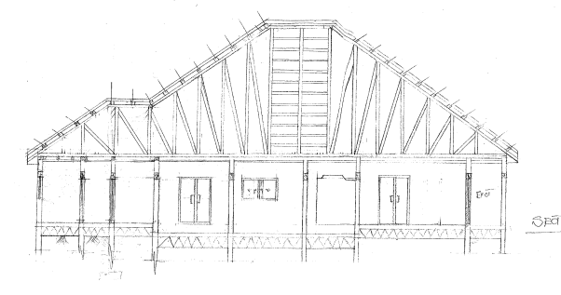

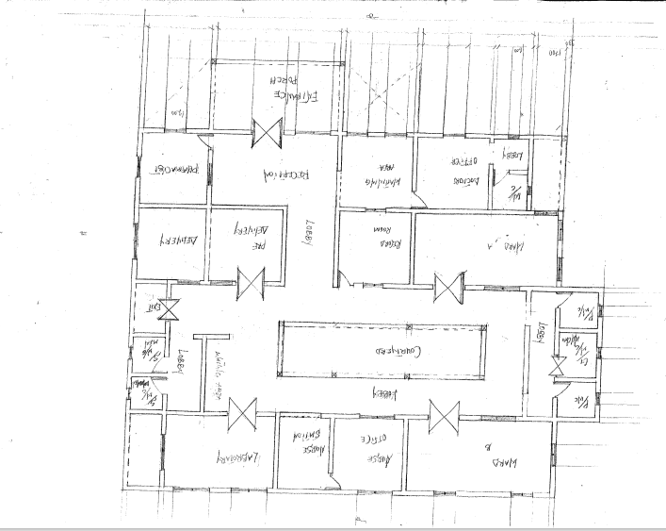

**CHAPTER FOUR**

**4.0 SUMMARY, RECOMMENDATION AND CONCLUTION**

## 4.1 PROBLEMS OBSERVED DURING MY PROGRAM

1. The time frame set for the program is too short as some of the aspects of the program where not completed.
2. Lack of Financial support from the company to aid transportation to and from training.
3. Attentions are not given to the IT students by the workers it is learn if you want to learn or ask if you want to know.

**4.2 SUMMARY**

One would state that the discipline is the training of the mind and body towards effective performance. The Students Industrial Work Experience Scheme (SIWES) is more or less achieving this fit. As it further builds on the theoretical classrooms leaving a practical approach of the industry and commerce to supply of finished goods and services. This program has enabled the participating students to be practically involved in the day-by-day activities of the industries and commerce.

Emphasis in the observation of industrial safety rules and regulations, time critical operation and proper man-hand management, quality cortices, etc. are daily activity objective. All those aimed at the production of marketable goods and services in the world of work.

However, to consolidate on the gains of this Industrial Training Fund (ITF) higher institution coordinator on SIWES program should be allowed making some suggestion and recommendation.

**4.3 CONCLUSION**

SIWES programme is very vital student especially undergraduates, because I come to see the SIWES programme provide an application of the theoretical knowledge learned by student in school to practical or real work situation. Also it is a medium where student from different higher institutions and department come together sharing idea there, by promoting an avenue for learning and them work.

**4.4 RECOMMENDATIONS**

Having being exposed to a bit of what entail working in an individual related to my course of study under SIWES programme I wish to make this recommendation

1. Higher instruction of learning especially either institution and universities should establish link with comprise and establishment so as to provide space for student on industrial attachment, with the option of gaining employment in future, by doing so, it will go a long way in alleviating suffering and difficulties encountered by student in securing place for individual attachment.
2. Student should put money as the primary aim of going SIWES programme, there is more to learn than Bain allowance.

**REFERENCE**

Chudley, R. (2005). *Construction technology* volume 2. Pearson Prentice Hall, New York.

Edward, B. (2003). *The Effect of SIWES on a student*, Federal Ministry of Works, Lagos. Nigeria.

Francis, K. (2012). *Building Construction Illustration*. (Fourth Edition). Wiley Publisher. ISBN-10: ‎ 9788126535637.

Obande, M. (1990). *Blocklaying and Concreting*, 2nd Edition. Pearson Education Limited, Harlow United Kingdom. ISBN13 9780582025417.